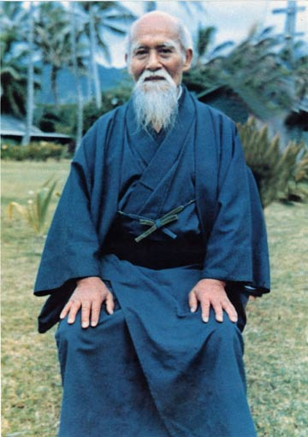
Morihei Ueshiba, founder of the Aikido and ascended master citizen of Shamballa.

AIKIDO REIKI

AÏKIDO : "Aï" : harmony; "ki" : spirit ; "do" : way

"Aï" means also love; "ki" : interne energy ; "do" : way > the way of the heart ☺

« Let the energy guides you… », Morihei Ueshiba
« Almighty me ?
My power, i have it from God. I unite and surrender like a child, my parents are great ! »
« Handle everyone like you would handle a baby, gently and with unconditional love at all time. Be at peace at all time. »
«Aikido is a prayer in movement »
«Aikido is the art of peace, of fighting without fighting, the art of unconditional love and enlightenment »
« Once you are full of love, there is no place for the will to fight anymore, you are living in a world of peace, a life only full of peace. »

http://en.wikipedia.org/wiki/Morihei_Ueshiba
http://www.youtube.com/watch?v=XPDJ1dfxoQA
http://en.wikipedia.org/wiki/Aikido

Pour les français, lisez ceci : http://www.reikiforum.com/reiki-aikido.htm
Et ceci : http://www.aikidolebouscat.fr/Aikido/Ueshiba.html
Et encore ça : http://www.aikidolebouscat.fr/Aikido/Ueshiba.html#Par1

Reiki, is the heart way.
Aikido is the art of love too : the art of fighting without fighting.
You see the truth, you are encircled by yourself, there is no opponents.
Would you fight yourself or love yourself ?
The Art Of Peace by Morihei Ueshiba is a great book for its wisdom.

If you got into energy by first studying martial arts, qi gong, maybe even Aikido, Budo…This one is for you !
It will give you a connection with Aikido’s founder, student of the similar spiritual school Usui Mikao went to : the Shingon MIKKYO Buddhist school. Both are japanese ascended masters and experienced enlightenment (= “kurama”) in the mount KURAMA. Your heart will be also united with Usui and Buddha as well as Ueshiba. Three major masters of our era ☺

If you do not do any form of physical energy work such as yoga or qi gong...activate it to meditate and have assistance during healing session. It connects you to the heart of Usui and Ueshiba and Buddha, our new earth logo.
Originally it was meant to because a martial art master using the aura work to play instead of the will and the physical strenght. it's been so when i created it for me. And a year later, i shared it here, and as i was writing the manual, i added 2 hearts. It brings great peace.
I activate now and forever the aikido reiki to receive all its benefits for all that i am for my highest good and greatest good.
If you teach/study martial arts, qi gong...please talk about this attunement, gift the manual so that everyone receive it.

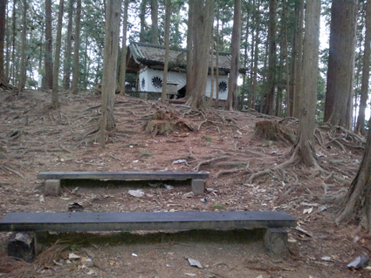
the mount KURAMA
Do you feel the energy, the original, purest Usui reiki emanating from this picture ?

Mikao had 3 major experiences such as his awakening and his ascension of course, and a life pretty unsual. He was born fragile and become just the strongest ☺ and lived like a child always in joy. Watch him on youtube. One day, he met Onisaburo DEGUCHI, a famous powerful healer of the Omoto Kyo spiritual school (Shinto spirituality). He became his spiritual teacher and brought spirituality into his life. Onisaburo DEGUCHI was a man of dialogue for global Peace...

A few inspiring videos about what love is when you can think “ki”
http://www.youtube.com/watch?v=XoDK3XuvZWw
See how vividly he moves and yet look old.
See how he does not use his body to touch and throw his opponents.
He unites in love with them and let the energy flow. It is not anymore the power of the will over love or the mind that uses all the physical strength, but a human full of his soul love and letting it flow with an intention as simple as a smile.
I personally live it as a dance, a very fluid, effortless dance.

If you have chakra awareness, settle in your heart chakra and expand it as well as your crown chakra to the infinite then make the crown chakra pouring down its energy into your body, and use only your intent to move your body with your heart chakra to move just like you intent to smile to people and think with a gentle intent that you want to walk ahead, then think “backward” and play with all directions. If you want to dance, dance, but don’t think more. Feel. The state of mind and the force of the focus to use the intent is nothing, you do it everyday when you intent to drink your glass of water, or look at the sun. Got it ? That simple. Don’t think. Enjoy the sun, the water, the flow.

I walk all the time like this, in addition, I learnt the qi gong way of walking to rise my energy.
http://www.youtube.com/watch?list=UUBgeZpyjtmyLdPwWCzaW9Cg&feature=player_embedded&v=RS81NFirSCw

I walk like that all the time, i don't do it sometime as a training, I made it my natural way again. Find a qi gong master to understand it (and wuji) beyond what you can see at the moment. It keeps the flow great.

And I stand like that, it’s called wuji and it’s the basic of the tree qi gong. http://www.youtube.com/watch?feature=player_embedded&v=y07FauHYlmg
To be grounded like a god, think this : "God please, put me in a tube your light perfectly and infinitely and bring me down all the divine tools i need with perfect timing always, do your will for me dear God for my highest and greatest good. Amen".
It’s the best grounding method ever, just perfect !

Wuji is wonderful to heal and to reach stillness of the mind, you then realise your true nature is not to think ever ! You just know ☺ If you are with ease standing in wuji, not using your muscles anymore but you are bothered with your mind. Do the meditation below. You can do it also each time you want to take a nap, feel tired, start and end your day, while in the plane...
This meditation, once you handle is better to recharge than taking a nap. By doing it, even 5 minutes only, you will heal perfectly. You can even imagine be sitting near someone, touching his/her shoulders, and both of you will heal. You can even imagine all of your family sitting around you, all will heal in this state. It does because it puts you in oneness with your soul and you are offering this oneness.
So sit or relax on your bed...or anywhere ! Start simple, do it for less than 5 minutes many times when you can (later, you may do it for 30 minutes, and then, for ever, back to who you truly are) :

* close your eyes, let wander your thoughts
* watch your thoughts like you would watch the sea on the beach, or the flower moved by the wind. Notice, but do not pay attention, like a kid, see without thinking, let the film go on.
* don’t try, don’t do. Surrender without question to observe.
*…your thoughts will become more quiet, slower, disappear with time, even in seconds
* continue to observe whatever happens
* soon you enter a calm state, a moment between each thought. You notice a space, a pause, a silence between each sound, thought, picture.
* taste that new state of silence. Catch it, taste it to remember.
* Deepen this empty moment. You’ve already been there right ? Look into your memories…maybe with friends, maybe in a park, maybe just walking, or sitting in summer.

* Lost it ? No problem, observe this new thought, let it pass by. The movie is still playing. Another silent moment is coming for sure.
Stay in it and you’re done. Do this many time, to get back to that state. The more you stay in it, the more you are healing yourself, and awakening. No control, just pleasure to be here. An awaken person just stays in it always. Why not you ? It’s not hard.
Accept to stop thinking, accept to stop controlling, and accept to stop wondering.
“yes, but why ? How ? what if ?”No, surrender, relax. The more you relax and surrender, the more all answers come to you. Always.

Here is a meditation that will bring you great awareness on your own energy so the aikido reiki can guide you
It helps you to relax deeply, to rest, to shift to your lightbody easily once you mastered it, you reach the state when you’re feeling like being on a cloud, and not feeling anymore you physical body, wondering why you don’t feel your body anymore ^_^
You might wish to set protection before and be opened to meet your guides eventually.
''For my highest and greatest good I invoke archangel michael to perfectly protect me from everything that is not for my highest and greatest good and i call the masters of shamballa to come in circle around me to be my protectors, sentinels and healers. I ask God to send me the guides i may need now. Thank you."
(It's just an idea)

So lay down, focus on your breath (belly) deeply, slowly, just relax. Don’t think. Breath. You can say in your mind “Sooo” when you breath in, and “Hammmm” when you breath out” if you want to calm down more.
After a few minutes, when you feel you are ready...
Feel your body, start with your hands maybe. You will either shift in a global sensation of heaviness, like falling deep deep deep, or rising, literally like on a cloud.
You may need to do this meditation daily for months of course before to master it. Do it 15 min to 1 hour. Just enjoy it. And ground back when you get up.
What I do now is simply remember the feeling from the best time I did this meditation, and I put this feeling back in my hands, then others parts of my body. I focus on this wonderful feeling to feel light like a feather, and relax, enjoy, surrender.
This is a very good moment to talk (under God’s protection) with your guides, angels, spirit, soul, even if you don’t hear them. They always do. (even with your inner child).
And then Ask God to make you feel heaven. Ask him this seriously and enjoy it.
It funny to notice that you will really wonder where is your physical body, even if you open your eyes, because you will see it, but if you move a little bit gently your fingers, hands…you won’t feel them.
To end it, bring back your awareness to your breath and physical parts, move them, breath in a energetic way, start to move.
Get up and ground a lot.
Ultimate mastery to this to me is being able to get in to that state in a second with and NLP anchoring technique wherever, and to start walking in that state. A walking meditation. Basically to get into it quickly, i just remember the feeling and open to it.
If you do, end it with grounding.
KNOW, that the more love you are, the more you can feel the energies. Remember to love yourself a lot and in joy! Successful egoist people are those you are joyful. And the most successful of them are those who loves themselves equally. Their pitfall is often to love themselves only for the glamorous part of life, but not for casual areas, like work. Even them need to love equally.
For the one interested in the external, physical approach, the best you can do is to watch the whole tv program called “samurai spirit” about aikido on the nhk tv.
http://www.youtube.com/watch?v=VyPf_hdrF2A
and join a Dojo. But if you don’t live in Japan, then seek your dojo with the school budo raji international
http://www.ecoledebudoraji.ro/en/~EBRinternational_en.html

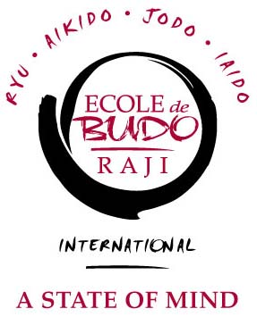
It is good to balance, but not better than anything. Ultimately all martial arts are a way to the ascension and with this “reiki”, you will be more in awareness of the energy directly. I wish to give the ability to play with the auras like big ballons pushing each others ☺
http://www.youtube.com/watch?v=KJr2BdUTYkU

Of course everything come in perfect timing as you walk the unconditional love path and ascend. Forget the powers because it will lower your vibration the ego would be holding you down), just enjoy the life like a child, and enjoy the rewards God gives you as you simply use your creativity to make your divinity shine everywhere and express your light and your infinite love in all manners you can imagine. You are here for no reason else. Make heaven in you with love and joy.

For the attunement, just read this simple words :

“ Yes Aikido reiki ”

Receive the attunement, then activate it (just think “aikido reiki”) and let the energy guides you in your training, in your life. It is a way to explore by yourself, to see through the mystery ☺
If you meditate (activate it and intent something. Remember you receive because you ask) and receive messages, have dreams, see maybe the master, or his son still incarnated Mitsuteru Ueshiba which a friend saw ☺ http://www.youtube.com/watch?v=w9V6DAVMq0A
…come and share, always, because it’s time to be your true self, an unconditional Giver/receiver.

If you wish to understand the grounding process…
If possible, sit or stand with both feet flat on the ground or floor. Visualize your Earth Crust Chakra, which is approximately 10 to 12 inches below your feet. Now visualize the core of Mother Earth, the Core Crystal, shining a Brilliant Yellow Gold color. See the Golden Yellow Earth Core Energy extend up through a Pillar of Light to your Earth Crust Chakra. Also visualize the Bright Red Life Force Energy of Mother Earth all around the Pillar of Golden Yellow Light.
Bring the Red Life Force Energy to mix with the Golden Yellow Energy of the Core Crystal. The mixing of the energies produces an Amber colored Light. Pull this Amber colored Light up to your Earth Crust Chakra. As the energy fills this chakra to overflowing, pull the energy up your left foot and your right foot, into your legs and up to your hips. Fill your Root Chakra and your hips with this energy. Now, move the energy down your opposite legs, the energy that came up the right leg goes down the left leg and vice versa. See the energy drain down both legs, through the feet to your Earth Crust Chakra and all the way back to the core.
See the energy begin to move in an unbroken stream, up your left leg, into your hips and Root Chakra and drain back to the Earth Crust Chakra and down to the earth’s core. See a continuous loop without any gaps. Simultaneously, see the same is happening up you right leg, into your Root Chakra and hips, down your left leg to the Earth Crust Chakra and then down to Earth’s core in a continuous cycle.

The object of the exercise is to have two streams of Amber Light continually moving through your Root Chakra and hips, moving in both directions at once, keeping you grounded and your Root Chakra clear with an ever replenishing flow from Mother Earth

Enjoy \oOo/

If you teach/study martial arts, qi gong...please talk about this attunement, gift the manual so that everyone receive it.

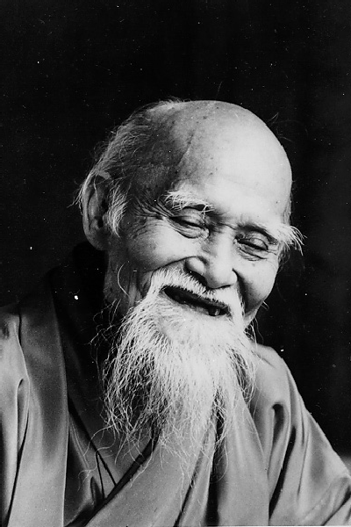

Share it in unconditional love
Do not sell
And you will be a master.

